**TASK ON VPC-2**

1.Create one VPC,with 1 one public subnet and 1 private subnet

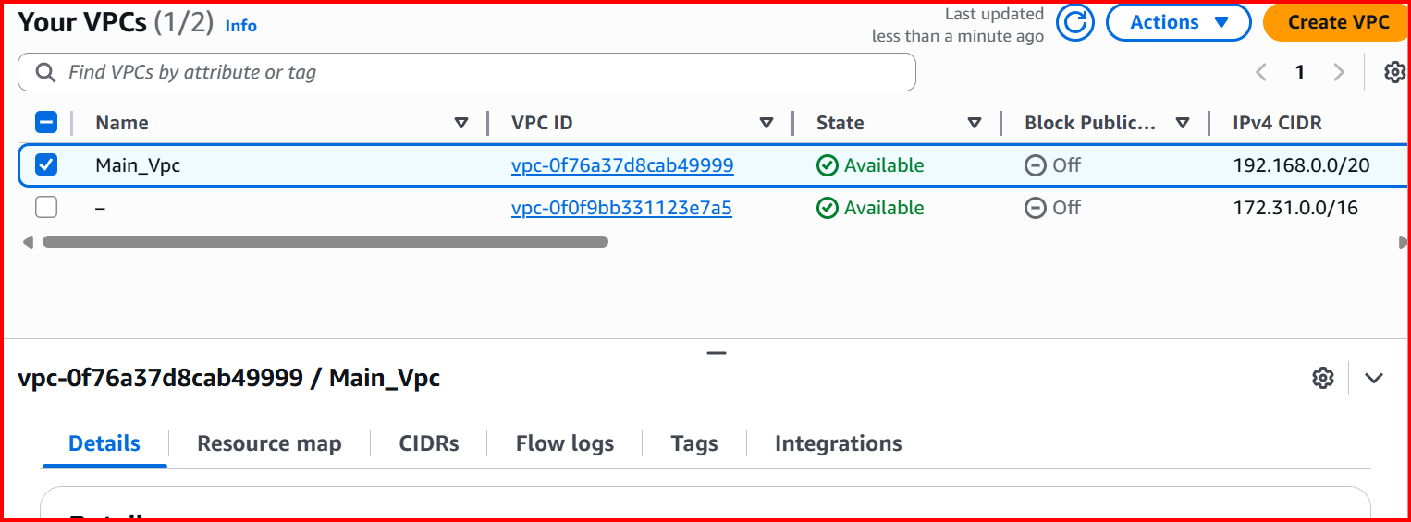

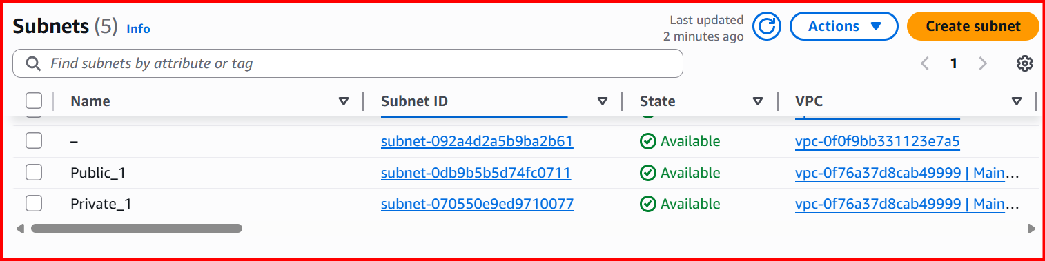

2. Enable VPC peering for cross region.

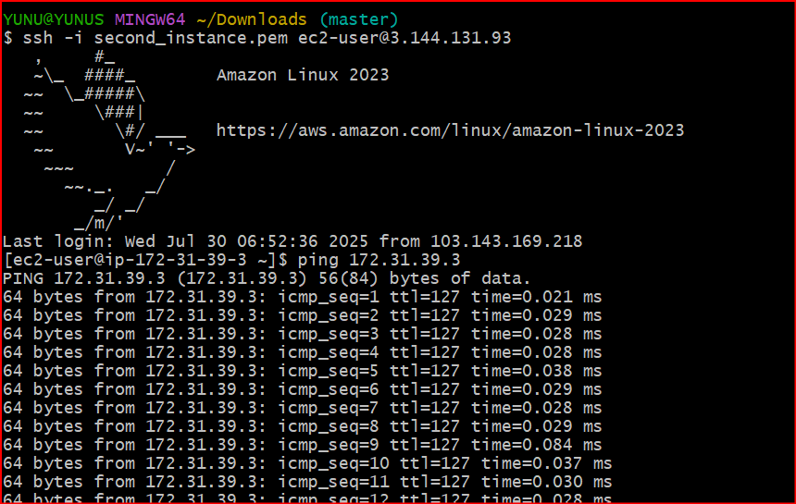

3. Enable VPC peering for cross account. (You can collaborate with your friend and do this task).

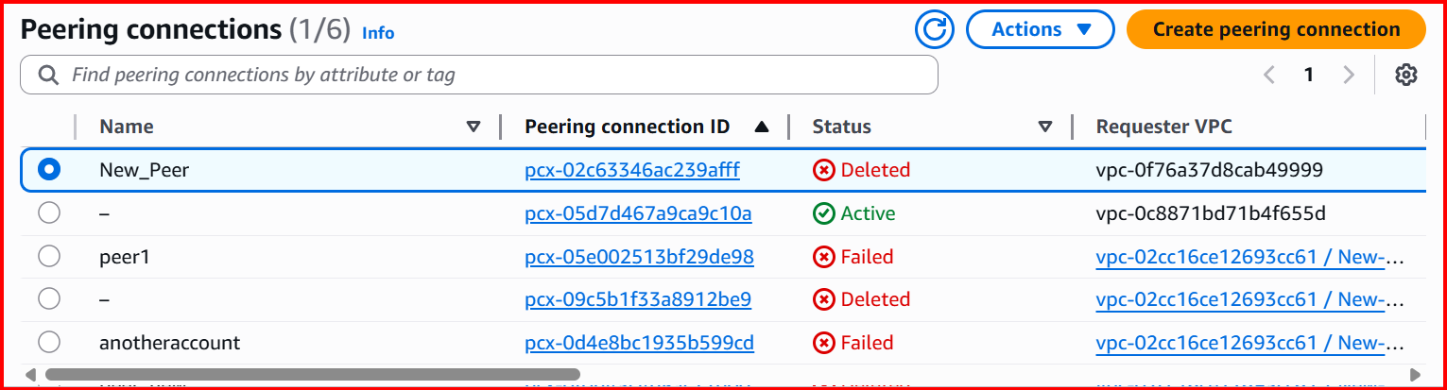

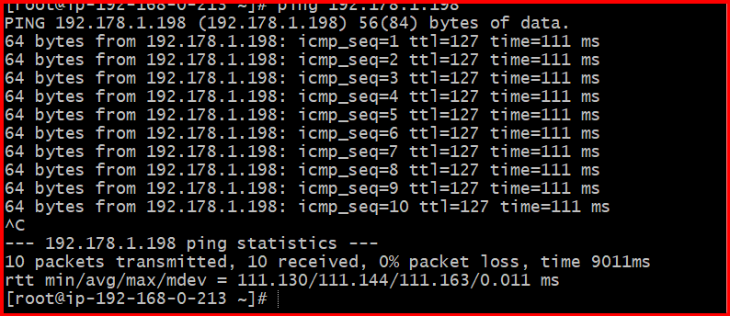

4. Setup VPC Transist gateway.

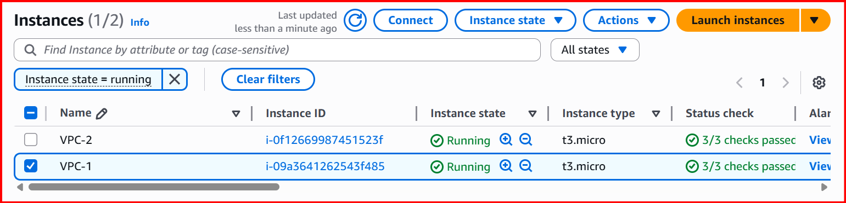

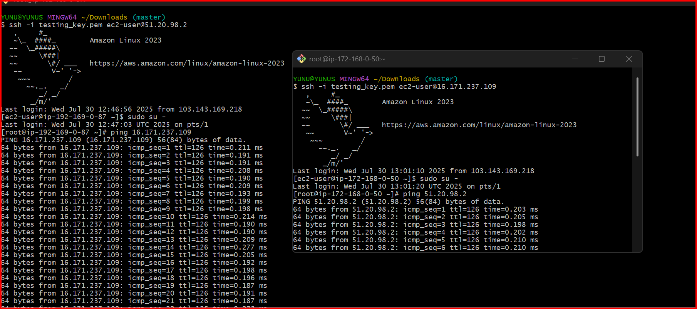

5.Setup VPC End Point.

